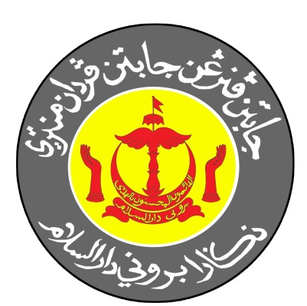

GUIDELINES FOR STUDENTS ON ATTACHMENT TO THE DEPARTMENT OF INFORMATION

- OFFICE HOURS

  - Office hours are from 7.45am to 12.15pm (morning session) and from 1.30pm to 4.30pm (afternoon session) for students who are not carrying out field work. For students who are assigned to field work, office hours will depend on the length of time given for the work in hand.

  - Report to the Head of Division/Unit/mentor on Day One of your attachment to the Department of Information.

  - Log In and Log Out your time of arrival and leaving each day on the Log Book provided by the Department of Information.

  - Please inform the Head of Division/Unit/Mentor in case you need to leave during office hours for any unavoidable reason.

  - Please submit your Medical Certificate (“MC”) to the Head of Division/Unit/Mentor in case you are on sick leave.

  - Please submit in writing, either through letter or email, to the Head of Division/Unit/Mentor in case you need to leave the country at any point during your attachment to the Department of Information.

  - You will be reported to your school/university/institution of higher learning in case you are absent without leave.

- ASSIGNED TO A DIVISION OR UNIT

  - Please speak to the Student Attachment Coordinator at the Research and Development Unit (URD) in case you have issues while being assigned to a Division or Unit.

  - Pease complete the evaluation form provided by the Department of Information at the end of your stint.

  - Surf the website, www.penerangan.gov.bn OR www.information.gov.bn for more information on the Department of Information and its products and services.

  - You can download out mobile app, InfoDept.BN in order to access information on our sovereign, Brunei Darussalam in general, the Department of Information, prayer times, Pelita Brunei Online, Pelita Brunei E-paper, Main Headlines, where to get a copy of Pelita Brunei, press room, branch offices, video gallery, Brunei Dairy, Info-Foto Gallery, job vacancies, helplines, forum and the Department of Information calendar of activities.

  - Surf www.pelitabrunei.gov.bn to access the latest news on Pelita Brunei Online.

  - Access the following social media to view the latest information on the Department of Information, departmental activities, the latest news, videos and photographs:
Facebook of the Department of Information, Prime Minister’s Office, Brunei Darussalam
Instagram: infodept.bn
Twitter: infodept_bn

- DRESS CODE AND CONDUCT

  - Office attire:
    - For males, long sleeved shirt or MIB shirt and a pair of dark trousers. Short hair.
    - For females, modest but elegant clothing (i.e. clothing that do not exposes your limbs and parts of your body that are deemed inappropriate for the workplace).

  - During your attachment to the Department of Information:
    - Please carry out your work sincerely, with integrity and be polite and courteous.
    - Please cooperate with the Head of Division/Unit/Mentor.
    - Please DO NOT misbehave during office hours at the office premises such as playing video games.
    - Please use office equipment with care.
    - Please DO NOT bring outsiders into the office premises at all times.

- OTHER MATTERS

  - Confidentiality. You are prohibited from disclosing official information that are deemed confidential or secret. Disclosing such information is a CRIMINAL OFFENCE under the Official Secrets Act.

  - You are welcomed to use the following facilities:
    - Penerangan Resource Centre.
    - Prayer room (surau) at the First Floor of the main building of the Department of Information.
    - Dewan Pengiran Setia Negara (sports hall)

  - You are welcomed to attend events hosted by the Department of Information such as the tahlil and doa arwah and become a volunteer.

  - You are expected to be willing to work outstation when instructed.

  - Turn off your computer and room air conditioner before you leave the building after the end of office hours. No wasteful use of office stationery.

  - Please inform the Student Attachment Coordinator in case you have health issues.

For any questions, you may contact the following:

Student Attachment Coordinator
Research and Development Unit
Department of Information
Old Airport, Berakas BB3510
Brunei Darussalam

Tel: (+673) 2383 400 / (+673) 8900 737
Fax: (+673) 2382 242

